2APHY: Nuclear Physics End of Unit Assignment ANSWERS

Name: _________________________________________________ ( 53 + 2 marks)
OVERALL – 2 marks for units and significant figures.
- As part of a laboratory write-up, a student was describing the three types of radiation. The paragraph they wrote is below but parts are missing. Using the information in the paragraph fill in the missing information. (4 marks)

There are three types of radiation; two are particles, the first of which is like a helium nucleus with two protons and two neutrons which is called __alpha______ radiation, has the symbol _α__and the nuclide_ 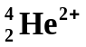___. The second particle is a high speed electron from the ______nucleus ____ of the atom which is called ___beta_____ radiation. It has the symbol β and the nuclide __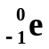__. The third form of radiation is not a particle but part of the electromagnetic spectrum. This type of radiation called __gamma___ radiation and is high energy electromagnetic radiation with the symbol ___γ_____ and the nuclide __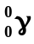___. – ½ mark each incorrect – 4 marks
- Complete the following table. (3 marks) 1 mark for each row correct – 3 marks
Radiation symbol | Name of radiation | What it is
β | beta | High speed electron
α | alpha | Helium nucleus
γ | gamma | Electromagnetic radiation

- Radon has a half-life of 3.80 days. In an experiment, a student starts with a sample containing 16.0 mg of radon. What would the mass of radon be after 11.4 days? (2 marks)

Half-life = 3.80 days A = A₀ (0.5)^{n}
A₀ = 16.0 mg = 16 x (0.5)³
Total time = 11.4 days = 16 x 0.125
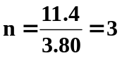 A = 2.00 mg (3sf)
1 mark for n 1 mark for answer

- One of the reactions that may ultimately be harnessed in nuclear fusion power generation involves the production of helium 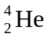 from deuterium 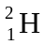 and tritium 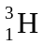 :

+ → + ?
What else is emitted from this reaction when producing helium-4? _neutron; 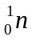______ (1 mark)
- Complete the following equations in the space provided and name the radiation produced.

a. 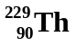 → 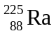 + 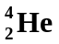 _____Alpha radiation_________ (1 mark)
b. 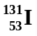 → 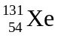 + 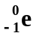 _____beta radiation________ (1 mark)
c. 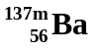 → 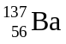 + ______gamma radiation________ (1 mark)

- Uranium-239 decays through a chain of nuclei, leading eventually to lead-206. The effective half-life for the whole process is about 4.50 x 10⁹ years. Some of the oldest uranium-bearing rocks on Earth contain roughly equal numbers of atoms of Uranium-239 and Lead-206 .If we assume that all of the lead-206 has come from the decay of uranium-239, approximately how old are these rocks? (2 marks)

As half of the Uranium-239 had turned into Lead-206 and the definition of half-life is to change one element into another, then one half-life had passed.

Age of rocks = 4.50 x 10⁹ years. (3sf) 2 marks

- Complete the following. (4 marks) 1 mark for each row correct - 4 marks
Element | Nuclide | Atomic Number | Number Of Neutrons | Mass Number
Carbon-12 | 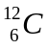 | 6 | 6 | 12
Nitrogen-13 | 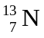 | 7 | 6 | 13
Nitrogen-14 | 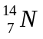 | 7 | 7 | 14
Cobalt-60 | 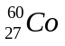 | 27 | 33 | 60

- Two of the elements above are isotopes of each other. Which are they and why are they isotopes?

The two isotopes are nitrogen-13 and nitrogen-14. 1 mark

Isotopes are atoms of the same element (atomic number) but with different numbers of neutrons (different mass number). 1 mark

Here, both are nitrogen, but nitrogen-14 has 7 neutrons while nitrogen-13 has 6 neutrons. 1 mark

- What is the value of Y in the possible fission reaction shown below?

+ 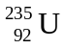 → 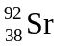+ 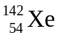+ Y .

What is the value of Y? _____2________ 1 mark

- Using an example, explain what ionizing radiation is and its effect on the human body. (2 marks)

Alpha radiation is ionizing radiation in that when it strikes a neutrally charged molecule within the human body, it can cause it to become an ion e.g. water becomes hydrogen ions and hydroxide ions. 1 mark

These ions are highly reactive and can cause unnecessary reactions within the body which may led to cancer. 1 mark

- An industrial worker accidentally inhaled a radioisotope with an activity of 255 Bq. The substance swallowed has a very long effective half-life and therefore the activity will not change significantly during the worker’s lifetime. Every decay of the isotope releases 1.35 x 10⁻¹³ J of energy into the body and the radioisotope is not eliminated from the body. Determine the amount of energy absorbed in one year by the worker from this substance. (1 year = 365 days) (2 marks)

Energy = activity x energy x time in seconds 1 mark
= 255 x 1.35 x 10⁻¹³ x 365 x 24 x 60 x 60
= 1.09 x 10⁻³ J (3sf) 1 mark

12. A worker in a nuclear accident receives 45.5 J of radioactive energy from an alpha source. His
mass is 75.0 kg. (Quality factor for alpha is 15.)

- What is his absorbed does? (1 mark) b. What is his does equivalent? (1 mark)

Absorbed dose = energy = 45.5 = 0.60666 dose equivalent = absorbed dose x QF
Mass 75.0 = 0.60666 x 15

Absorbed dose = 0.607 Gy (3sf) Dose equivalent = 9.10 Sv (3sf)
1 mark 1 mark

- Should he be seriously concerned? Explain (2 marks)

Unfortunately yes. 1 mark
A dose of 9.1 Sv would be fatal and he would die within a very short time. 1 mark

- The radio isotope 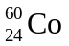has a half-life of approximately 5.5 years. Gamma radiation from a source is used to treat cancer. Hospitals using such sources for therapy usually replace the source when its activity has fallen to 12.5% of its original value. After how many years must a source be replaced? (2 marks)

Half-life = 5.5 years 2^{n} = A₀ = 1.0
A₀ = 1 A 0.125
A = 0.125 2^{n} = 8
n = time n = 3 1 mark
half-life time = half-life x n
= 5.5 x 3
time = 17 years (2sf) 1 mark

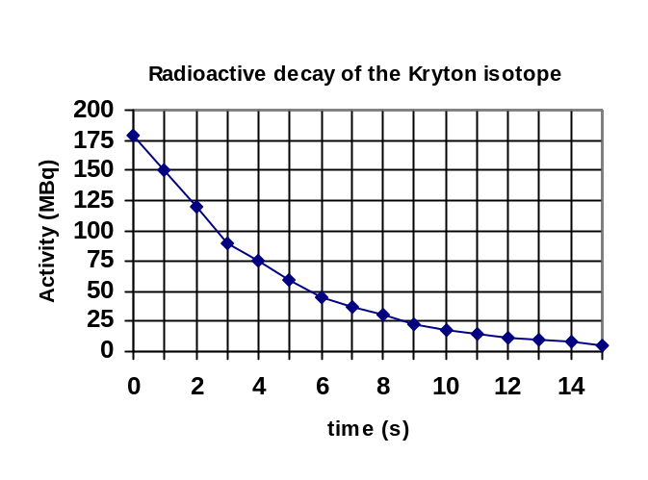12. An isotope of Krypton is being studied by a university student. He records the activity of the isotope as it decays and draws the graph shown.

a. What is the half-life of the isotope?
about 5 seconds (1 marks)
b. Does the isotope have a high or low
activity rate? _____High_____________
(1 mark)
Explain your answer.

The activity is high as the half-life is so short, about 5 seconds. 1 mark

This means that every 5 seconds, half of the atoms will decay to another element. A low activity will have a long half-life. 1 mark

- When an alpha particle bombards nitrogen-14, oxygen-17 is formed. Calculate the binding energy per nucleon, firstly in MeV and then in joules, of one oxygen-17 nucleus. (5 marks)
Mass proton = 1.00728 u
Mass neutron = 1.00867 u
Mass oxygen-17 = 16.99474 u

Oxygen-17 = 8 protons and 9 neutrons

Mass defect = mass of components – mass of nucleus
= [(8 x 1.00728) + (9 x 1.00867)] - (16.99474)
= 8.05824 + 9.07803 - 16.99474
= 0.14153 u 1 mark

energy MeV = 0.14153 x 931
= 131.8 MeV 1 mark

Per nucleon = 131.8 ÷ 17
= 7.75 MeV 1 mark

Mass defect in kg = 0.14153 x 1.6606 x 10⁻²⁷
OR

energy in joules = MeV x 1.6 x 10⁻¹³
= 7.755 x 1.6 x 10⁻¹³

= 1.24 x 10⁻¹² J

= 2.3502 x 10⁻²⁸ kg

Energy = mc²
= 2.3502 x 10⁻²⁸ x (3 x 10⁸)²
= 2.115 x 10⁻¹¹ J

Energy per nucleon = 2.115 x 10⁻¹¹ ÷ 17
= 1.24 x 10⁻¹² J

2 marks for energy in joules

Comprehension: (10 marks)
Read the passage below then answer the questions that follow passage. This passage is adapted from Microsoft Encarta Reference Library 2002.

THE BASICS OF NUCLEAR POWER

Nuclear power plants generate electricity from fission, usually of uranium-235 (U-235), the nucleus of which has 92 protons and 143 neutrons. When it absorbs an extra neutron, the nucleus becomes unstable and splits into smaller pieces and more neutrons. The products and neutrons have a smaller total mass than the U-235 and the first neutron; the mass difference has been converted into energy, mostly in the form of heat, which produces steam and in turn drives a turbine generator to produce electricity.

Natural uranium is a mixture of two isotopes, fissionable U-235 (0.7 per cent) and non-fissionable U-238. However, U-238 can absorb neutrons to form plutonium-239 (P-239), which is fissionable, and up to half the energy produced by a reactor can in fact come from fission of P-239. Some types of reactor require the amount of U-235 to be increased above the natural level, which is called enrichment. Pressurized water reactors (PWRs), the most common type of reactor, require fuel enriched to about 3 per cent U-235.

Reactor fuel is made up of fuel pellets or pins enclosed in a tubular cladding of steel, zircaloy, or aluminium. Several of these fuel rods make up each fuel assembly. The fast neutrons released in the fission reaction need to be slowed down before they will induce further fissions and give a sustained chain reaction. This is done by a moderator, usually water or graphite, which surrounds the fuel in the reactor. However, in “fast reactors” there is no moderator and the fast neutrons sustain the fission reaction.
A coolant is circulated through the reactor to remove heat from the fuel. Ordinary water (which is usually also the moderator) is most commonly used but heavy water (deuterium oxide), air, carbon dioxide, helium, liquid sodium, liquid sodium-potassium alloy, molten salts, or hydrocarbon liquids may be used in different types of reactor.

The chain reaction is controlled by using neutron absorbers such as boron, either by moving boron-containing control rods in and out of the reactor core, or by varying the boron concentration in the cooling water. These can also be used to shut down the reactor. The power level of the reactor is monitored by temperature, flow, and radiation instruments and used to determine control settings so that the chain reaction is just self-sustaining.

The main components of a nuclear reactor are: the pressure vessel (containing the core); the fuel rods, moderator, and primary cooling system (making up the core); the control system; and the containment building. This last element is required in the event of an accident, to prevent any radioactive material being released to the environment, and is usually cylindrical with a hemispherical dome on top.

During operation, and also after it is shut down, a nuclear reactor will contain a very large amount of radioactive material. The radiation emitted by this material is absorbed in thick concrete shields surrounding the reactor core and primary cooling system. An important safety feature is the emergency core cooling system, which will prevent overheating and “meltdown” of the reactor core if the primary cooling system fails. See Also Nuclear Fission.

- The TDS rules are always used in nuclear reactors. What are the TDS rules? (2 marks)

T – decrease time of exposure
D – increase distance from source
S – use shielding where possible - 1 each incorrect – 2 marks
- Nuclear power plants generate electricity from fission. What is fission and how does this result in a chain reaction? (3 mark)

Fission is the splitting of a large atom in to smaller atoms and the release of 2 to 3 neutrons. 1 mark

In a chain reaction, the unstable atom releases neutrons when it decays. 1 mark

These neutrons can strike other atoms causing the atom to undergo fission and release more neutrons and so on. 1 mark

- Write the nuclear equation for U-238 absorbing a neutron to form Pu-239. (1 mark)
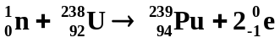 1 mark
- What is meant by “enriched” uranium? (1 mark)

Natural uranium is about 0.7% U-235 and the rest is U-238. Only U-235 will readily undergo fission when bombarded by neutrons so to increase the decay, natural uranium has more U-235 added to it. This is known as enrichment and the uranium is called “enriched” uranium.
1 mark

- Chain reactions are controlled by using neutron absorbers. If these were not in place, an uncontrolled chain reaction could take place if the uranium was at critical mass. What is critical mass? (2 marks)

Mass at which the neutrons from the decay of U-235 stay within the uranium and result in more fission reactions. 1 mark

Less than this, neutrons escape the mass and fission doesn’t readily occur. 1 mark

- Why do fast neutrons need to be slowed down in a nuclear reactor and what is used to do this? (2 marks)

Fast neutrons don’t induce further fission reactions, it is only when they are moving slowly and collide with U-235 will fission occur and hence a controlled chain reaction. 1 mark

This is done by a moderator which is usually made of water or graphite. 1 mark

